Street food Design in Public Space Gunung Sari Indah Surabaya

Rizka Tiara Maharani, Eva Elviana
UPN Veterans East Java
rizka.tiara.ar@upnjatim.ac.id

Abstract
The development of Gunung Sari Indah as a new neighborhood creates an impetus for increased housing and street food. Street food vendors set up shop on strategic roads to sell their products, causing crowds and traffic jams that disrupt the comfort. As a result, the focus of this research is on how to design street food in public spaces. This research uses the questionnaire, interview, and field survey methods. The questionnaire and interview are held to learn about the seller's aspirations for layout settings and facilities that they expect. A field survey is required to learn about the existing conditions, such as road width, seller position, and products offered. Furthermore, the issue of COVID-19 should be considered to avoid the virus from spreading in public places. As a result, the layout setting should be aware of new normal health protocols such as physical distancing, handwashing, and environmental hygiene. The street food layout setting will be formed by a color box mural with an area of one car parking lot 2.5 m x 5 m for one seller, resulting in a gap. Then, the East Road, which closes in the evening, will be the focus of street food. Nonetheless, signage is required for traffic management to reduce traffic congestion and provide comfort to visitors to this area.

Keywords: COVID-19, Design, New Normal, Public Space, Street food

Gunung Sari Indah is a housing complex in Surabaya's Karang Pilang district. This area serves as a link between West and South Surabaya. As a result, there is a housing development that is balancing the old kampong in the Gunung Sari Indah and Kedurus, Surabaya area. The expansion will have an effect on increasing housing complexes and then street food to meet the needs of residents. The street food in this area is not well organized.
In the Gunung Sari Indah area, the street food is occupying strategic areas, such as along the way, without regard for safety, either for the seller or the buyer. It will have many effects such as traffic jams, a crowded zone, and a decreasing visual environment due to the lack of scenery here make many effects due to the quality of street food service. A good environment will give many good positive rewards for utilitarian or hedonic values. On the other hand, this area previously had many numerous methods for controlling street food, but none of them have proven to be optimal. Furthermore, this issue requires a proper setting concept for governing the location of street food as well as the safety of traffic and users.
The definition of street food itself according to Karafir in Ali and Syamsu Alam (2012): “The street foods are small traders who selling in a public place such as the side of the road, parks, storefronts, and unlicensed markets efforts of the government". Starting from this statement, street foods are those who try in public places and do not get permission from the government. So, it needs an arrangement that includes several components such as location, trading time, the physical and kind of products street food, and the spread pattern of street food.
The determining the location of interest by the sector informal or street vendors are as follows, firstly, there is a people accumulation who doing activities together relatively the same time, throughout the day. Secondly, is a certain area being activity centers the economy of the city and are often visited in large numbers. Thirdly, it has the ease to happen relationship between street food with potential buyers even though carried out in a relatively narrow space. Lastly, the street food agglomerate at the vertices of wide pedestrian paths and places frequented by people in bulk close to the public market, terminal, or commercial area.
The trading time according to McGee and Yeung from research in Asian Cities Southeast shows that the pattern of street food activity adjusts to the rhythm of the characteristics of everyday people’s life. Determination of the time period of street vendors’ activities is also based on or according to the behavior of formal activities.
The physical means of trade and types of merchandise based on McGee and Yeung, is strongly influenced by the nature of the service street food. For instance, the kind of food for sale for instance food or drink. Furthermore, each type of facility trade has different sizes so the room size is different required. Room size effect in setting and spatial planning for street food.
Regarding McGee and Yeung, the distribution pattern of street food is influenced by agglomeration and accessibility. The activities will always take advantage of activities in the formal sector and usually, the shopping centers become one of the main pull the location of the informal sector to attract the consumer. As for the way street vendors are interesting consumers by means of group sales. The street food tends to do cooperate with others who the same type of merchandise or support each other such as food and beverage vendors. The grouping of street food is also attractive to consumers because they can be free to choose the goods or services of the interested consumer. There are two categories of agglomeration which are focus agglomeration which is focused on one point and linear agglomeration which is occurred in along the main road. Meanwhile, accessibility, the street food prefers to be located along with the roadside major and frequented places pedestrians.
Besides the street food area, there are several physical settings that are needed in public spaces that can support community activity patterns, such as shade rooms, restrooms, activity rooms, accessibility, and night lighting. These elements are already present in the Gunung Sari Indah area, so they do not necessitate a large arrangement. Some of the trees on the east side of the area, close to the street vendors area, provide shade. The rest and activity areas are located in the grassy area in the center. Roads and street lights have been installed to improve accessibility and lighting. As a result, the layout of this area is focused on providing traders with the amenities they require.
Another factor to consider is COVID-19, which has been in effect since 2020 and has resulted in numerous changes and adaptations in the public space. The quarantine and self-isolation process is one of the prevention of transmission of the virus from one person to someone else. Besides that, the issue of lockdown causes limited human access to work as usual. Thus, the public area becomes very important in a residential environment for facilitating outdoor activities for residents such as sunbathing or exercise.
Public open areas alone provide a lot of benefits for both physical and mental health. The hope is that the COVID-19 pandemic will increase the government's appreciation for managing parks that is in town. This pandemic has also caused the new habit is social or physical distancing. This habit is recommended by WHO and governments to reduce virus transmission. Based on the regulations of Ministry of Health No. 09 of 2020 regarding Guidelines Large-Scale Social Restrictions, social distancing can be applied with restrictions on holiday activities, offices, and restrictions on public facilities in open areas.
On the other hand, according to the WHO, social distancing can be applied with a distance of 1 meter for each individual and avoiding crowds, shutting out life when sneezing or coughing, staying indoors, and wearing masks when working outside. It becomes very important to do in the new normal era as a new custom related to protocol health. Apart from that, there are several ways to do this to prevent the spread of the virus in open spaces public. One that can be applied is by putting hand washing sinks at several points in the room public. In addition, by providing a marker for doing social distancing on space elements public such as in the street area or the chairs in the room public. Notice boards in the form of banners or posters can also be used to warn visitors about the importance of keeping their distance.
This study aims to identify the best design solution for street food in the Gunung Sari area. Moreover, a good design will give a good impact on the users. The consumers will more interested in the ambiance and convenience of coming to the street area. Furthermore, the food quality will be improved so that it will give an advantage for sellers, especially for their business and economic growth. So, the novelty of this research is how to make a good design through marking pattern exploration for the street food that is using health protocols.

I. METHODS
To create a geometry design, a pattern-based framework is used. In this framework, design is produced by analyzing patterns from existing designs via material selection, building elements, building parts, or building types. There are four steps in a pattern-based framework. The first is a reduction judgment criterion, which is used in this study through questioners, interviews, and a field survey to determine the primary problem with tools for instance paper and camera. Questioners are given for knowing the aspiration from each of them. The question is about the background of the seller, is are they need an arrangement, and most importantly what additional facilities are needed. After knowing and analyzing the judgment criteria, the data will be used in the next stage.
The second step is to identify patterns and types by learning about the material choices and public space elements in pre-existing designs that have been adapted for COVID-19 through literature surveys by journals and precedent design. In the pandemic era, the socioeconomic and public health crises will alter the design of public space, management, use, and perceptions in a variety of ways, both across and within cities. In open space, public space and health policy also should be considered in the design. So, the designing of public spaces should aware of those issues.
The third step is an exploration of context, elements, and parts, which involves exploring and analyzing the design as architectural parts and validating them through journals. In this case, the pattern that is explored is about how to make a design separation in the public area due to health protocols. The separation can be used through marking in public elements for making privatization areas for each person. Finally, the last step is to assemble the proposed design that resulted from this research. Figure 1 depicts a diagram framework used in this study.
Following the completion of the design through the assembly step, the final step is implementation, which is then handed over to the customer. The customer is the Gunung Sari Indah complex's housing management by Rukun Tetangga / Rukun Warga (RT/RW). This stage is contained several steps as the first is prepared especially for permitting. Secondly is to communicate with the management for making the solution of design and the third is to hand over and communicate the design result to be applicated in the field.
The product that should be given is a booklet containing proposals for street food design, facilities such as handwashing stations, waste bins, and signage design. Except for the hand wash, which is purchased and done by fabrication, all products are made by costumed design. The first step in reducing judgment criteria is to select those facilities that are requested from sellers via the questionnaire results that are provided.
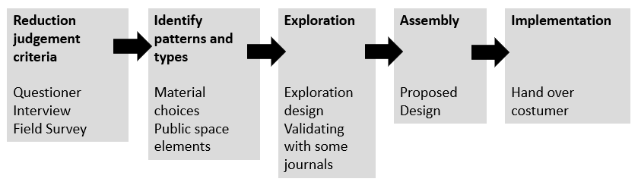
Figure 1. Methods
Source: adapted from Pattern-based Framework

II. RESULT AND DISCUSSION
A. Reduction Judgement Criteria
The purpose of the reduction judgment criteria is to identify the primary problem that has occurred in the location area. The interview and questionnaire are distributed to 20 street food vendors and include the seller's identity, location, and inspiration for both the seller and the visitor. According to those activities, 65 percent of respondents (the street food vendor) want an arrangement as shown in Figure 2. This is due to the fact that a more organized environment will draw the attention of more customers. Moreover, as many as 60% want to collaborate with various types of products that will complement each other. The collaboration that is wanted such as food sellers collaborating with drink sellers. So that, the customer is easy find their need when they buy some foods, they will not difficult to find the drink too. Of course, this condition will give benefit both consumer and seller.
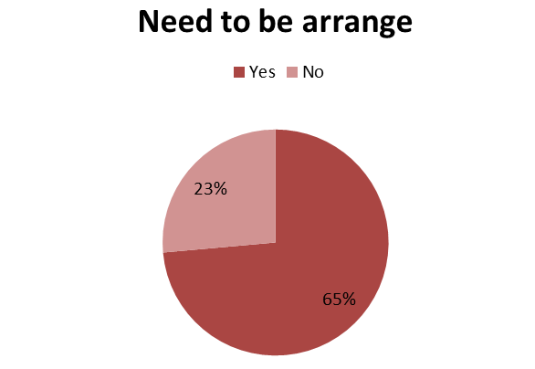

Figure 2. The Number of Street Food Merchants who wants to be an arrangement
Source: Authors, 2021
Another aspiration from the seller is additional facilities. The questionnaire resulted that as many as 27% and 25% of sellers require additional amenities such as handwashing and waste bins as shown in Figure 3. Hand washing is needed for cleaning their hand before entering the public area. Furthermore, another sanity such as a public toilet is needed to be located in public spaces also needed by the seller. Nevertheless, sanities are also a highlighted issue that is needed in public space during COVID-19.
Waste bins are also needed to collect their trash before going to the landfill. Previously, in this area many trash are untidy. It will disturb the visual environment and make people uncomforted to do many activities here. If the surrounding location is well arranged, it will give an increased value so that people can pleasant to be here.
11% of the seller needs electricity facilities to be distributed for each cart. The electricity is needed especially for lighting their cart or using a blender for making juice. So, it also should be provided for making it easy for sellers in the process of preparing their stuff. Nevertheless, a parking lot will be arranged due to as many as 7 % of sellers need to do it. The arrangement is started from the analysis of a traffic area in order to guide the visitor and avoid traffic jams.
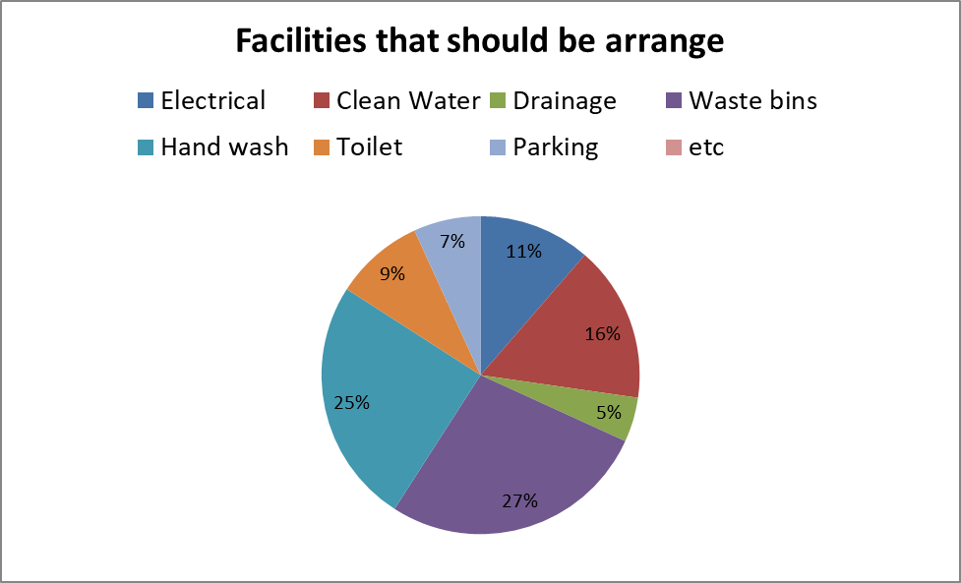
Figure 3. Facilities that need to be arranged
Source: Authors, 2021

Drainage is also needed to be fixed regarding 5% of sellers want it to be arranged. If the high rain seasons are coming, the water will have smooth distribution. So that, the area will not have puddles or floods. Nevertheless, this research will provide some aspirations from sellers to be designed in a public area in order that the area will have a good ambiance and convenience.
The next step in this stage is a field survey to aid in the analysis of the process as it relates to the current condition. The observation consists of analyzing traffic and public space conditions on both the road and in the park as illustrated in Figure 4. Furthermore, there are three main roads in this public space, one of which will be closed after 6 p.m. to control visitors and vehicles entering the housing complex. This condition will give an advantage because it can be used as a street food area for selling their products here. This relocation is equivalent to street use and time for selling street food in the evening. As a result, both the seller and the buyer will be satisfied with this relocation plan in terms of security, safety, and comfort.
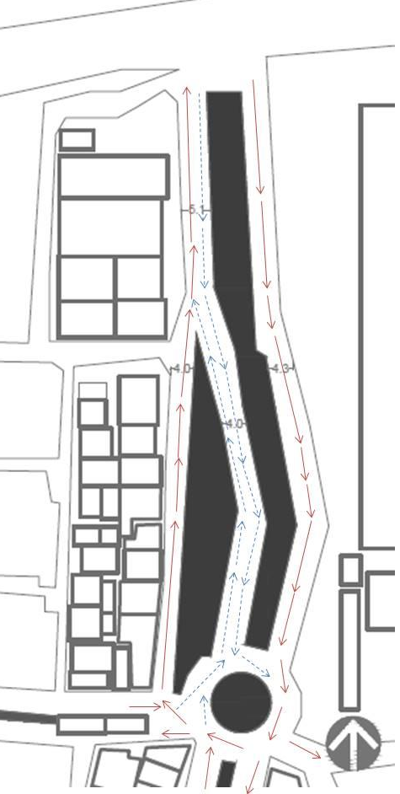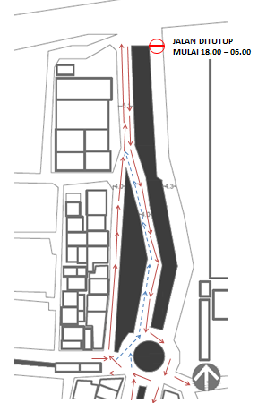

Figure 4 The Traffic Analysis
Source: Authors, 2021

With the accumulation of visitors, street food, and vehicles, the central road becomes congested so that as shown in Figure 5, a control system via signage is required to direct visitors when they enter the housing complex. Furthermore, the street food will relocate to East Road because it is an empty space in the evening, ensuring the safety of both visitors and sellers. The agglomeration in this design is made linear so that will have occurred along East Road. Furthermore, the parking lot also can move into East Road so that the parking lot on West and Middle Road will reduce and make the traffic freeway fluently.

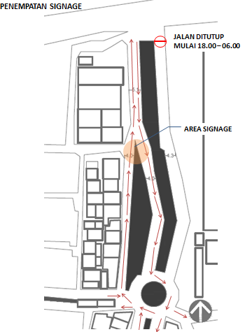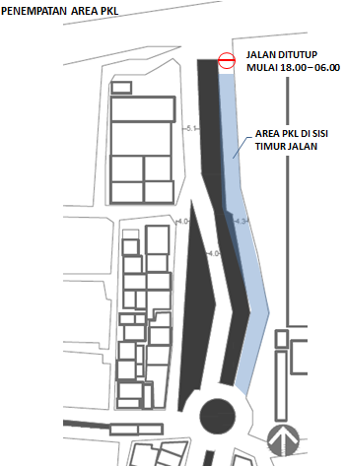

Figure 5 Signage and Street Food Location Concept
Source: Authors, 2021

B. Identify Patterns and Types
The thought of relocation is temporary as a result of questioner and interview that is implemented with field survey and instruction from local housing management such as RT and RW because there are many seasonal sellers here. It means that the seller will arrive in the evening on a cart, motorcycle, or even a car. After arranging their product, the street food vendor will begin selling items such as food, drink, toys, and so on. Every seller will fulfill on the East Road and visitors can freely access the public space.
The design concept for revitalizing the street food area stems from the identity pattern in public spaces, particularly in light of COVID-19. The design should be mindful of health protocols in order to maintain the physical distancing practice. Physical separation should be used, with a distance of one meter between each person. This is a critical point to be aware of in the new era.
Because of the awareness of physical distancing, the street food area will have more space in this study, as illustrated in Figure 6. The identity pattern was inspired by an existing public space in Malioboro and the domino park concept in New York. As a result, it is possible to get a distance between people who mark off from coloring in the ground. Color will give many physiological perceptions for example giving a strong visual effect and having a trend such as women is preferring to choose soft colors and men to bold colors. So that exploring the many colors of the mural boxes will interest all people. As a result, the concept of the street food area in this study is mural box color to mark off the seller area and make it more space. Color also brings another psychological effect to the user such as calm or refresh during the pandemic.
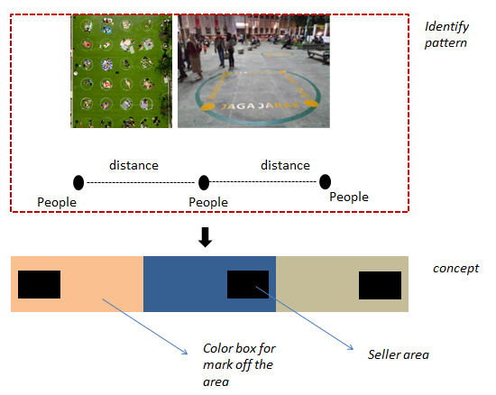
Figure 6 pattern concept for street food area
Source: Authors, 2021
C. Exploration
The exploration is developing with the pattern concept that is described before in point B (Identify patterns and types). The pattern regarding people’s distance, WHO has a recommendation for giving one to two-meter space as physical distancing for every user. The distance can be as a marker in the ground through coloring or symbols that make people notice differences in-between spaces.
The strategy that is done in this project is making rectangles with color differences. The one rectangle has a size of 2.5 m x 5 m or 12.5 sqm that will be filled by one seller. One seller will have one color box. So, physical distancing can be applied indirectly with this strategy. Nevertheless, each seller has the freedom to arrange their product or cart display. Even though each seller needs a different size, 12.5 sqm is assumed can meet all the space requirements of each trader.
The color selection refers to the soft and bold color that is related to gender tendency. Women with soft colors like dusty orange and blue mist. Then, a man with red-orange and black blue. Color has a psychological effect due to can give a resonate with people’s perceptions. So that, colorful scheme Pantone is very useful to be applied in public spaces for making a distance.

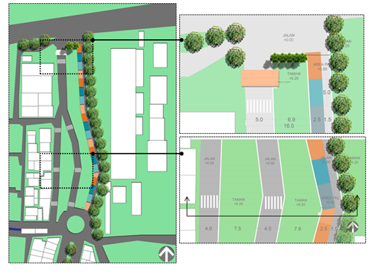
Figure 7 Street Food Design
Source: Authors, 2021

D. Assembly
The street food design will be located on East Road through a mural color box as illustrated in Figure 7. Moreover, the public space area is very large. There is a separation between the West area into the East area. So, it needs a liaison in order for West and East can be linked through a zebra cross.
A zebra cross also can give space to the pedestrian in order to them feel secure when crossing the street as illustrated in Figure 8. The green area in the middle also can be used as a public or interaction room to activity the visitor who comes to the site area. So that, people from all gender and age can play here freely for instance sport, sit, or play with others.
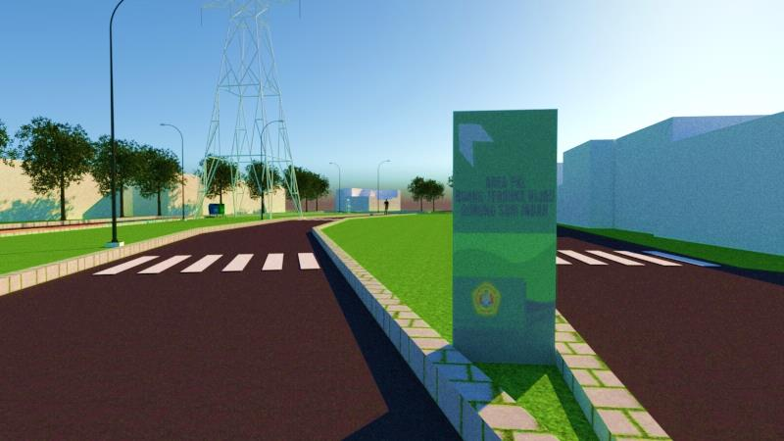

Figure 8 Zebra Cross
Source: Authors, 2021

Regarding the reduction judgment criteria, there are so many additional facilities that are needed by users, especially by sellers. Additional facilities like handwash and waste bins will be provided in this devotion research. A handwash will be located in the street food area as shown in Figure 9 and a waste bin will be provided at several points in the public space area. The addition of those facilities is also supporting health protocols that should be considered in the pandemic era.
The design of the sink/hand wash basin uses a tread system to turn on the water and soap. For the procurement, the team chose to buy ready-made items at one of the sink/handwashing shops in Surabaya, taking into account the experience of the shop that has often made these items so that the quality they get is good. The selection of the model design for the sink uses a portable system with a stomp so that when you wash your hands, you don't need to hold the faucet and soap bottle, but simply use the stomp on your feet. The specifications of the sink/washbasin itself consist of a cubical frame made of stainless-steel frame box 760x500x150 mm and a faucet barrel box frame and sink 395 x 395 x 575 mm along with poles. The dimensions of the 75-liter water tub, are 38.5 x 36 x 54.5 cm, the sink 33x48x13 cm, and the frame itself is 75x48x1050 cm.
The location of the trash cans will be spread into 3 points by considering areas with a lot of crowds to make it easier for them to dispose of their trash. The manufacture of the material for the trash can itself by utilizing the waste of a used paint bucket measuring 20 liters and the frame is done by a welder, which can be seen in Figure 10. Each frame consists of two holes consisting of wet waste and dry waste. As a marker for each used bucket, a sticker is attached with the words wet waste and dry waste. The process of installing the trash bin frame itself is planted to make it sturdier and more difficult to be picked up by irresponsible people.

Figure 9 Hand Washing
Source: Authors, 2021

The signage is also should be provided on the middle road as shown in Figure 10. This signage design is proposed to guide the vehicle. So that, it can reduce the traffic jams that often happen here. The design for the Gunung Sari Indah Open Space signage/nameplates began with a brainstorming session led by the Lecturer, who produced concepts and design sketches. The point/location for placing the nameplate as shown in is based on the results of an analysis of existing conditions and traffic in the field as described before in the sub reduction judgment design criteria section. Furthermore, two students were responsible for the fabrication of the frame, which was submitted to the welder, as well as the design of the 60x120 cm banner layout. The nameplate serves not only as a signboard in this case, but it can also serve as an information board by replacing posters with slogans that educate the public (eg containing recommendations for washing hands and wearing masks, etc.).

D. The Implementation
The handover process is done in one day. The product that is delivered to the client or housing management (RT/RW) has consisted of 4 products. Firstly, is a booklet or design proposal which is contained the design concept of street food arrangement. If one day, the management will process the design, they already have a proposed design to be applied in the public area. Secondly, the hand wash is surrendered to the client and the installation location is near the security post to facilitate maintenance. Thirdly, the signage is located in a green area. Lastly, the trash or waste bins are placed at several points in the public area, especially in junctions or crowded spaces.
The challenge that is occurred in this devotion research is this activity is progress when delta Covid-19 virus is high during June-July 2021. So that, there is a limited time for us to meet offline together for discussing all the problems with stakeholders. The online platform is helping us to coordinate but it’s not always efficient. With all limitations that are happened, this devotion research can be finished well.
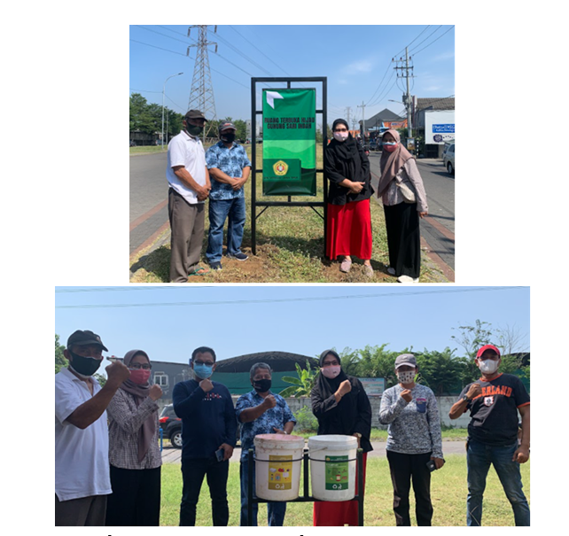

Figure 10 Hand over process to client
Source: Authors, 2021

III. CONCLUSION
The conclusion of this study is that street food design should adhere to the physical distancing term in order to reduce the spread of the coronavirus due to the pandemic situation. A mural color box can help users both seller and buyer to apply the physical distancing. It has happened because the differences in color can give phycological effects include in behavior. Even though each seller needs a different size but it can be assumed with a certain size can be applied to all sellers. The seller will have one color box and they have the freedom to arrange their product display. Furthermore, for supporting health protocols the handwashing stations and waste bins are two other amenities that can aid in the implementation. After that, for helping minimize the traffic jam in this area, signage can be applied for assisting the visitors in directing their vehicles.

IV. ACKNOWLEDGEMENT
This research is funded by LPPM Universitas Veteran Jawa Timur for Pengabdian Masyarakat through scheme Pemanfaatan IPTEKS Bagi Masyarakat (PIKAT) 2021. We also thank you to our clients in RW 6 Gunung Sari Indah, Surabaya.

V. REFERENCE
Aminnejad, Reza & Rosa Alikhani, “Physical distancing or social distancing: that is the question” (2020) 67:10 Can J Anesth Can Anesth 1457–1458.
Casas, Maria Carina & Dr Justine Chinoperekweyi, “Color Psychology and Its Influence on Consumer Buying Behavior: A Case of Apparel Products” (2019) 17.
Dewangga, Yordan Kristanto, Yuliastuti Amijaya & Hoseo Viadolorosa, “The Dynamics of Urban Public Space Perception in the New Normal Era” (2021) 5:1 9.
Gupta, Vikas, Kavita Khanna & Raj Kumar Gupta, “A study on the street food dimensions and its effects on consumer attitude and behavioural intentions” (2018) 73:3 Tour Rev 374–388.
Hadi, Suprapto et al, “Penataan Pedagang Kaki Lima, Arus Lalu Lintas Dan Ruang Parkir Di Jalan Teri Kota Tegal” (2020) 5:1 J Keselam Transp Jalan Indones J Road Saf 75–88.
Harrouk, Christele, “Domino Park Introduces Social Distancing Circles to Adapt to the COVID-19 Crisis”, (2020), online: <https://www.archdaily.com/940244/domino-park-introduces-social-distancing circles-to-adapt-to-the-covid-19 crisis?ad_source=search&ad_medium=search_result_all>.
Honey-Rosés, Jordi et al, “The impact of COVID-19 on public space: an early review of the emerging questions – design, perceptions and inequities” (2020) Cities Health 1–17.
Huang, Chen, “ROLE OF COLOR PSYCHOLOGY IN ART DESIGN” (2021) 33:5 Psychiatr Danub 7–240.
Jasiński, Artur, “Public space or safe space – remarks during the COVID-19 pandemic” (2020) Tech Trans 1–10.
Jurusan Arsitektur Fakultas Teknik Universitas Brawijaya & Muhammad Satya Adhitama, “Faktor Penentu Setting Fisik Dalam Beraktifitas Di Ruang Terbuka Publik ‘Studi Kasus Alun – Alun Merdeka Kota Malang’” (2013) 11:2 Rev Urban Archit Stud 1–9.
Koresponden, Penulis & Emily Email, “Gagasan Konseptual Ruang Publik untuk Meningkatkan Kesehatan Mental Saat Pandemi Covid-19” (2021) 9.
Plowright, Philip D, Revealing Architectural Design (Routledge, 2014).
Ranka, Miss Shikha, “How Corona Virus could Affect the Culture of Eating Special Reference to Street Food: THE NEW NORMAL” 8.
Seo, Kyung Hwa & Jee Hye Lee, “Understanding Risk Perception toward Food Safety in Street Food: The Relationships among Service Quality, Values, and Repurchase Intention” (2021) 18:13 Int J Environ Res Public Health 6826.

Kyung Hwa Seo & Jee Hye Lee, “Understanding Risk Perception toward Food Safety in Street Food: The Relationships among Service Quality, Values, and Repurchase Intention” (2021) 18:13 Int J Environ Res Public Health 6826.
Suprapto Hadi et al, “Penataan Pedagang Kaki Lima, Arus Lalu Lintas Dan Ruang Parkir Di Jalan Teri Kota Tegal” (2020) 5:1 J Keselam Transp Jalan Indones J Road Saf 75–88.
Ibid.
Ibid.
Ibid.
Ibid.
Jurusan Arsitektur Fakultas Teknik Universitas Brawijaya & Muhammad Satya Adhitama, “Faktor Penentu Setting Fisik Dalam Beraktifitas Di Ruang Terbuka Publik ‘Studi Kasus Alun – Alun Merdeka Kota Malang’” (2013) 11:2 Rev Urban Archit Stud 1–9.
Yordan Kristanto Dewangga, Yuliastuti Amijaya & Hoseo Viadolorosa, “The Dynamics of Urban Public Space Perception in the New Normal Era” (2021) 5:1 9.
Ibid.
Ibid.
Vikas Gupta, Kavita Khanna & Raj Kumar Gupta, “A study on the street food dimensions and its effects on consumer attitude and behavioural intentions” (2018) 73:3 Tour Rev 374–388.
Seo & Lee, “Understanding Risk Perception toward Food Safety in Street Food”, supra note 1.
Philip D Plowright, Revealing Architectural Design (Routledge, 2014).
Jordi Honey-Rosés et al, “The impact of COVID-19 on public space: an early review of the emerging questions – design, perceptions and inequities” (2020) Cities Health 1–17.
Artur Jasiński, “Public space or safe space – remarks during the COVID-19 pandemic” (2020) Tech Trans 1–10.
Philip D Plowright, Revealing Architecture Design (New York: Routledge, 2014).
Miss Shikha Ranka, “How Corona Virus could Affect the Culture of Eating Special Reference to Street Food: THE NEW NORMAL” 8.
Gupta, Khanna & Gupta, supra note 11.
Hadi et al, supra note 2.
Dewangga, Amijaya & Viadolorosa, supra note 8.
Ibid.
Christele Harrouk, “Domino Park Introduces Social Distancing Circles to Adapt to the COVID-19 Crisis”, (2020), online: <https://www.archdaily.com/940244/domino-park-introduces-social-distancing-circles-to-adapt-to-the-covid-19-crisis?ad_source=search&ad_medium=search_result_all>.
Huang, Chen, “ROLE OF COLOR PSYCHOLOGY IN ART DESIGN” (2021) 33:5 Psychiatr Danub 7–240.
Syenny & Emily, “Gagasan Konseptual Ruang Publik untuk Meningkatkan Kesehatan Mental Saat Pandemi Covid-19” (2021) 9.
Reza Aminnejad & Rosa Alikhani, “Physical distancing or social distancing: that is the question” (2020) 67:10 Can J Anesth Can Anesth 1457–1458.
Hadi et al, supra note 2.
Huang, Chen, supra note 23.
Maria Carina Casas & Dr Justine Chinoperekweyi, “Color Psychology and Its Influence on Consumer Buying Behavior: A Case of Apparel Products” (2019) 17.
Jurusan Arsitektur Fakultas Teknik Universitas Brawijaya & Adhitama, supra note 7.
Dewangga, Amijaya & Viadolorosa, supra note 8.

